Data
Analysis Report

Dated: 23-04-2026

Acknowledgement:
I would like to express my sincere gratitude to Dr. Iltaf Khan for his invaluable guidance, continuous support, and technical insights throughout the development of this project on the “Cars Details Dataset”. His mentorship was instrumental in helping me navigate the complexities of exploratory data analysis and predictive modeling, ensuring the professional quality of this final report.

Aiza Iqbal
(Data Analyst and Web Engineer)

Contents
Acknowledgement: 2
1. Introduction: 5
2. Import Libraries 5
Code: 5
Explanation: 5
3. Loading Dataset: 5
Code: 5
Explanation: 5
4. Dataset Overview: 6
Code: 6
Explanation: 6
5. Basic Information: 6
Code: 6
Explanation: 7
6. Data Cleaning: 7
Code: 7
Explanation: 7
7. Feature Engineering: 8
Code: 8
Explanation: 8
8. Basic Statistics: 8
Code: 8
Explanation: 8
9. Data Visualization: 9
(a) Price Distribution: 9
Code: 9
Explanation: 9
10
(b) Fuel Type Count: 10
Code: 10
Explanation: 10
(c) Price vs Year: 10
Code: 10
Explanation: 11
d) Transmission type: 11
Code: 11
Explanation: 12
e) Top 10 Car Companies 12
Code: 12
Explanation: 13
f) Transmission Distribution: 13
Code: 13
Explanation: 14
h) Correlation Heatmap: 14
Code: 14
Explanation: 15
10. Machine Learning : 15
a) Import Model Selection and Evaluation Libraries: 15
b) Define X and Y: 16
Code: 16
c) Train Test Split: 16
Code: 16
d) Train Model: 16
Code: 16
e) Evaluation: 17
Code: 17
Explanation: 17
11. Conclusion: 17

1. Introduction:
This report performs Exploratory Data Analysis (EDA) on a “Car Dataset” to understand patterns, relationships, and trends. The aim is to clean the data, analyze features, and prepare it for further modeling.EDA improves data quality and helps in making better decisions before applying machine learning.

2. Import Libraries

Code:
import pandas as pd
import numpy as np
import matplotlib.pyplot as plt
import seaborn as sns

Explanation:
These libraries are used for data analysis and visualization. Pandas handles data, NumPy supports calculations, and Matplotlib/Seaborn create graphs.
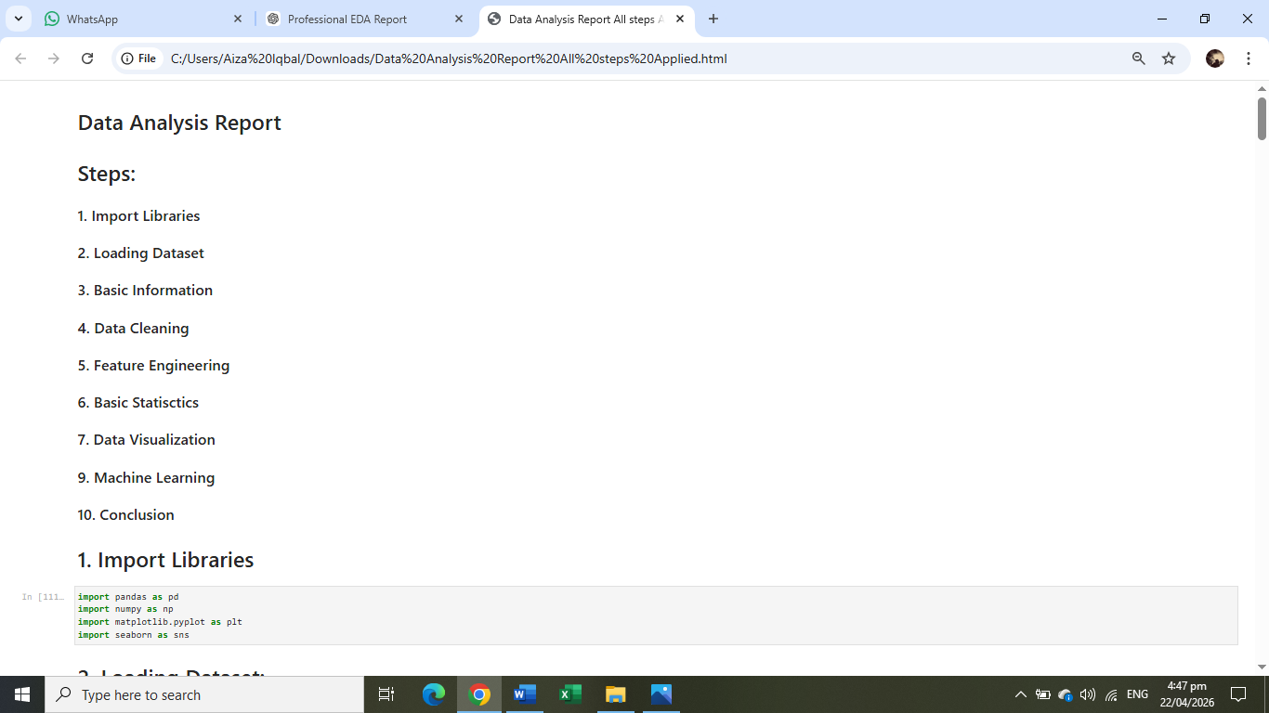

3. Loading Dataset:

Code:
df = pd.read_csv("car_data.csv")
df.head()
df.shape

Explanation:
The dataset is loaded into a dataframe. The head() function shows first rows, while shape tells number of rows and columns.
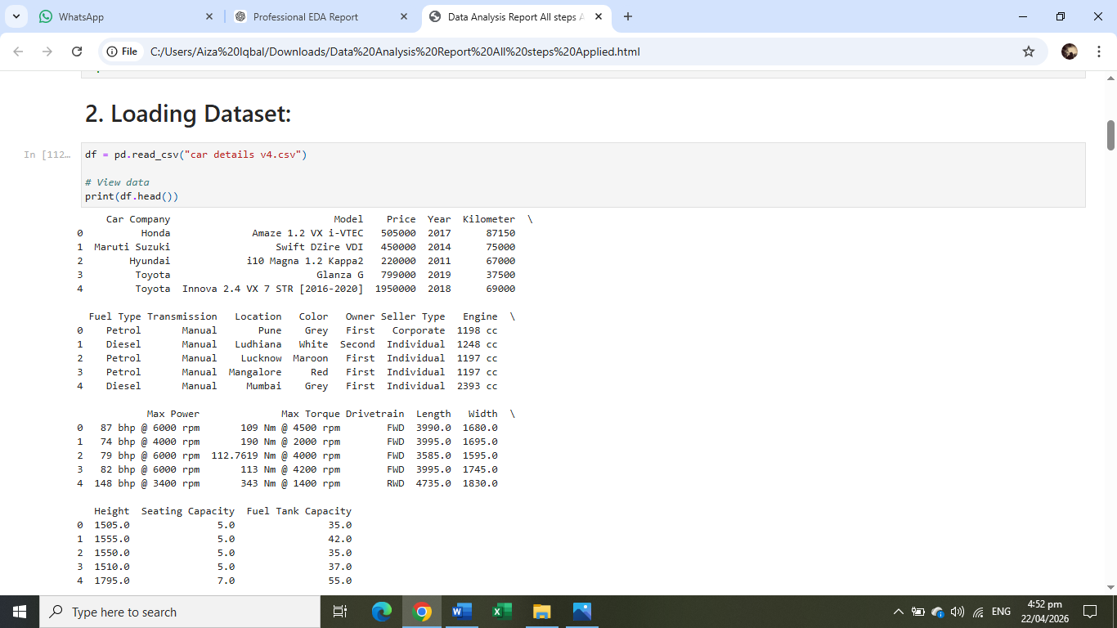

4. Dataset Overview:

Code:
df.columns
df.dtypes
df.shape

Explanation:
This step shows column names, data types, and size of dataset. It helps understand structure before analysis.

5. Basic Information:

Code:
print(df.shape) # rows, columns
print(df.columns) # column names
print(df.info()) # data types
print(df.describe()) # statistics

Explanation:
.info() shows missing values and data types. .describe() gives statistical summary like mean, min, max.
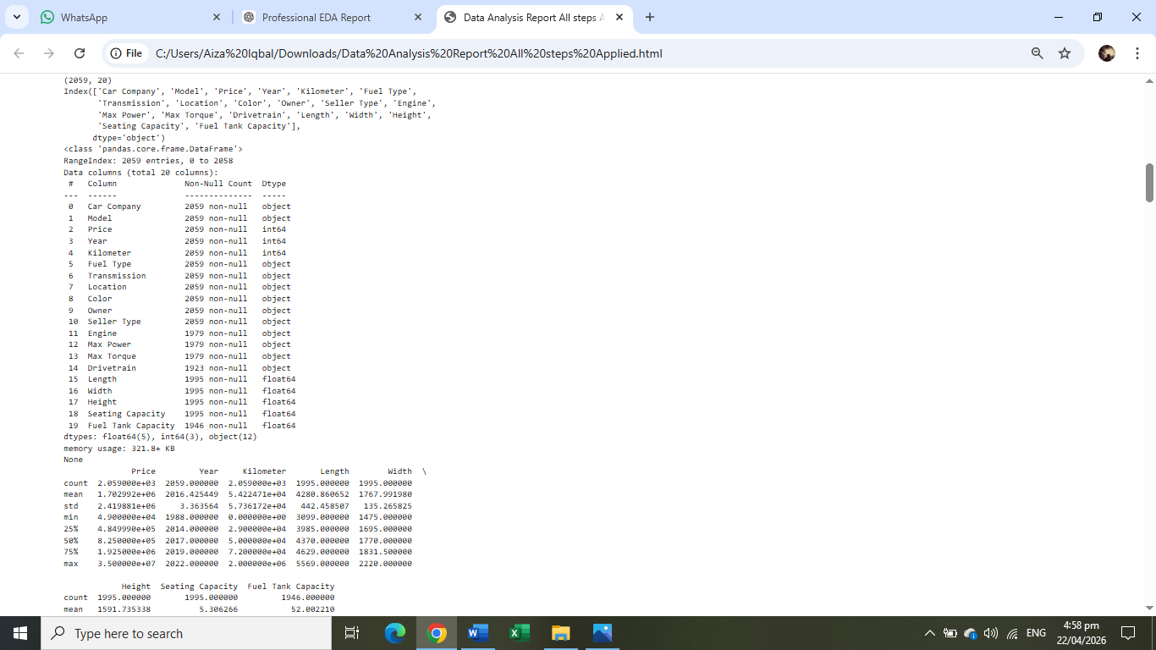

6. Data Cleaning:

Code:
# Check missing values
df.isnull().sum()
# Drop duplicates
df.drop_duplicates(inplace=True)
# Convert price to numeric
df['price'] = pd.to_numeric(df['price'], errors='coerce')

Explanation:
Data cleaning removes errors and improves quality. Missing values and duplicates are handled to ensure accurate analysis.
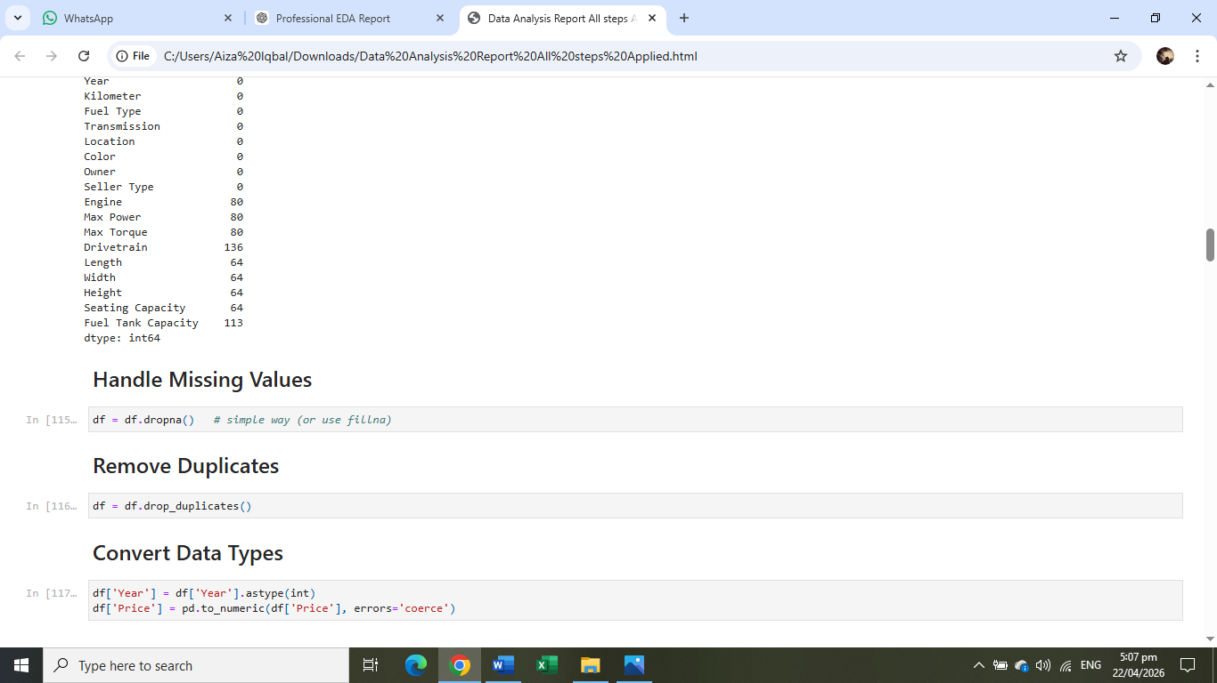
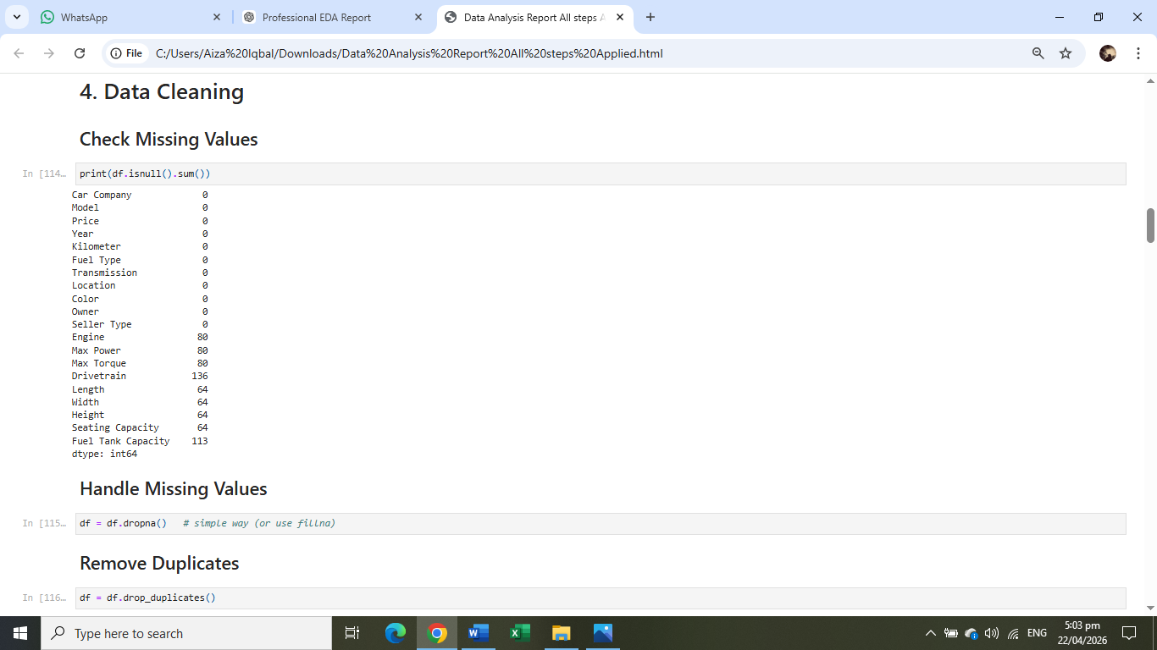

7. Feature Engineering:

Code:
df['Car_Age'] = 2024 - df['year']

Explanation:
A new feature "Car Age" is created. It is more useful than year for analyzing price trends.

8. Basic Statistics:

Code:
df['price'].mean()
df['price'].max()
df['price'].min()
Explanation:
These calculations help understand central tendency and spread of data, especially for price.
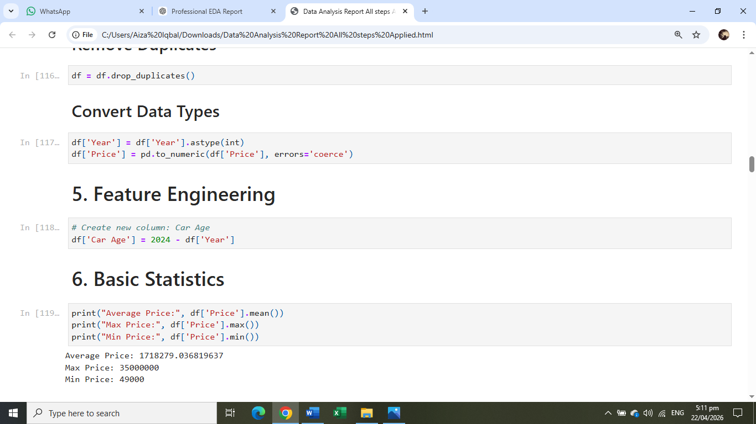

9. Data Visualization:

(a) Price Distribution:

Code:
plt.figure()
sns.histplot(df['price'], bins=30)
plt.title("Price Distribution")
plt.show()
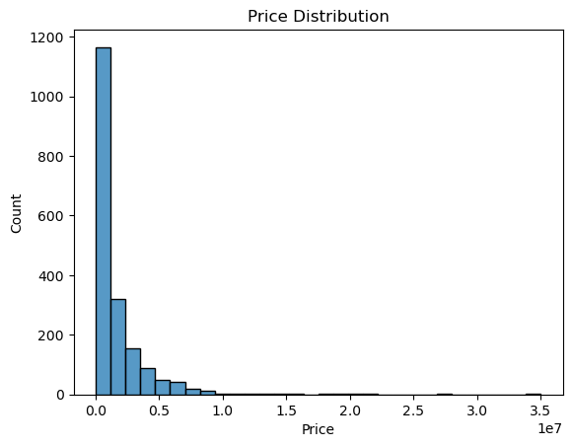

Explanation:
This graph shows how car prices are distributed and helps identify common price ranges.

(b) Fuel Type Count:

Code:
sns.countplot(x='fuel', data=df)
plt.title("Fuel Type Count")
plt.show()
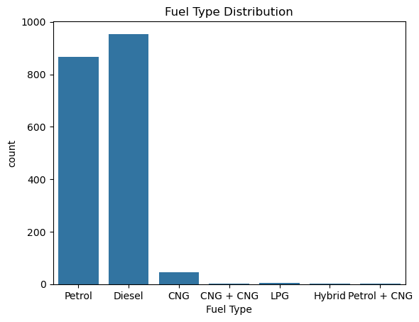

Explanation:
This shows how many cars belong to each fuel type category.

(c) Price vs Year:

Code:
sns.scatterplot(x='year', y='price', data=df)
plt.title("Price vs Year")
plt.show()
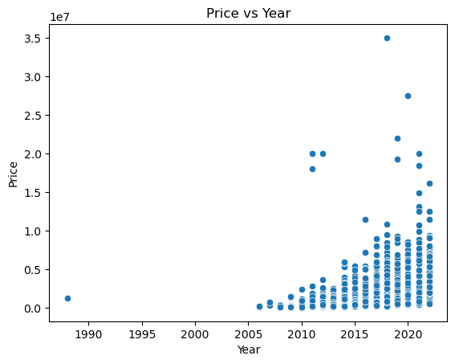

Explanation:
This graph shows relationship between car year and price.

d) Transmission type:

Code:
sns.countplot(x='Transmission', data=df)
plt.title("Transmission Type")
plt.show()
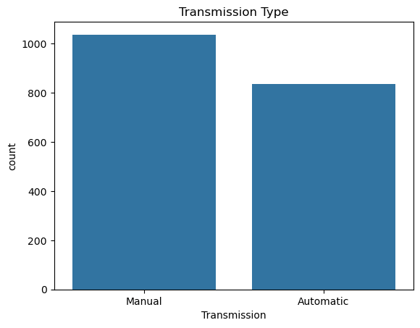

Explanation:
This chart describe the transmission of cars whether they are Manual or Automatic.

e) Top 10 Car Companies

Code:
plt.figure(figsize=(10, 6))
car_counts = df_clean['Car Company'].value_counts().head(10)
car_counts.plot(kind='bar', color='skyblue', edgecolor='black')
plt.title('Top 10 Car Companies')
plt.xlabel('Brand')
plt.ylabel('Number of Cars')
plt.xticks(rotation=45)
plt.show()
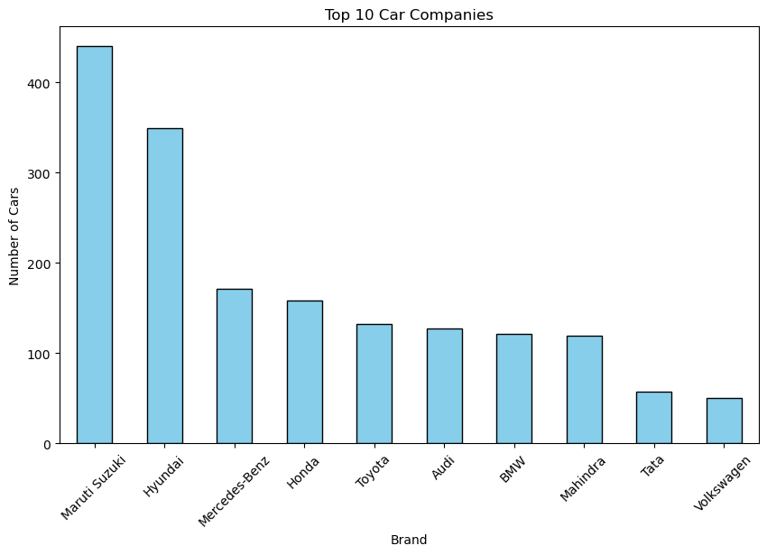

Explanation:
This Bar chart describes top 10 Car companies.

f) Transmission Distribution:

Code:
plt.figure(figsize=(5, 5))
trans_counts = df_clean['Transmission'].value_counts()
# The 'wedgeprops' creates the hole in the middle for the donut effect
plt.pie(trans_counts, labels=trans_counts.index, autopct='%1.1f%%',
startangle=140, colors=['#ff9999','#66b3ff'], wedgeprops={'width': 0.4})
plt.title('Transmission Distribution ')
plt.show()

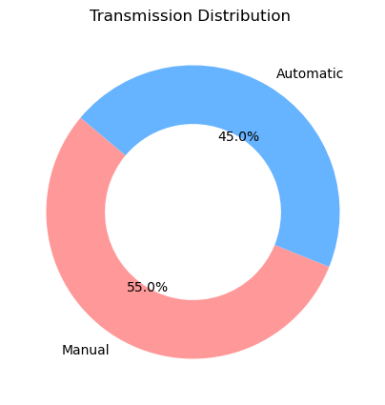

Explanation:
This Donut chart describe the transmission of cars that whether they are Automatic or Manual.

h) Correlation Heatmap:

Code:
plt.figure(figsize=(10,6))
sns.heatmap(df.corr(numeric_only=True), annot=True)
plt.title("Correlation Matrix")
plt.show()
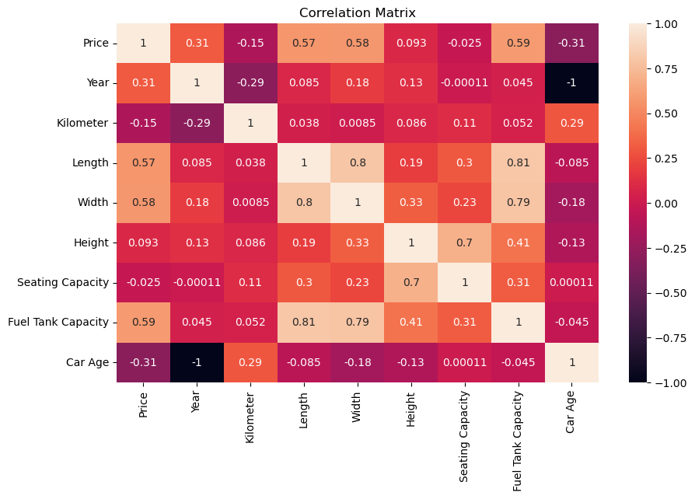

Explanation:
This correlation heatmap visualizes the strength and direction of linear relationships between car features, highlighting that Price is most strongly positively correlated with Fuel Tank Capacity, Width, and Length, while Year and Car Age exhibit a perfect inverse relationship.

10. Machine Learning :

a) Import Model Selection and Evaluation Libraries:
from sklearn.model_selection import train_test_split
from sklearn.linear_model import LinearRegression
from sklearn.metrics import mean_absolute_error, r2_score

b) Define X and Y:
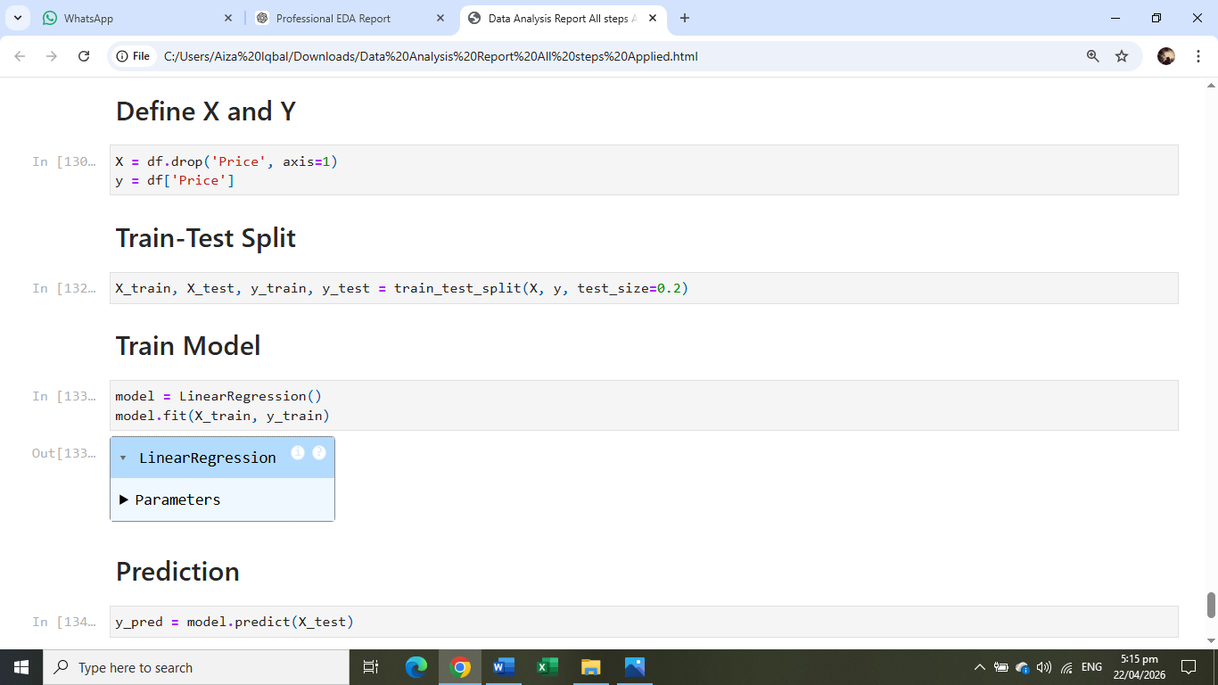
Code:
X = df[['year']]
y = df['price']

c) Train Test Split:


Code:
X_train, X_test, y_train, y_test = train_test_split(X, y, test_size=0.2)

d) Train Model:

Code:
model = LinearRegression()
model.fit(X_train, y_train)
pred = model.predict(X_test)

e) Evaluation:
Code:
print("MAE:", mean_absolute_error(y_test, pred))
print("R2 Score:", r2_score(y_test, pred))
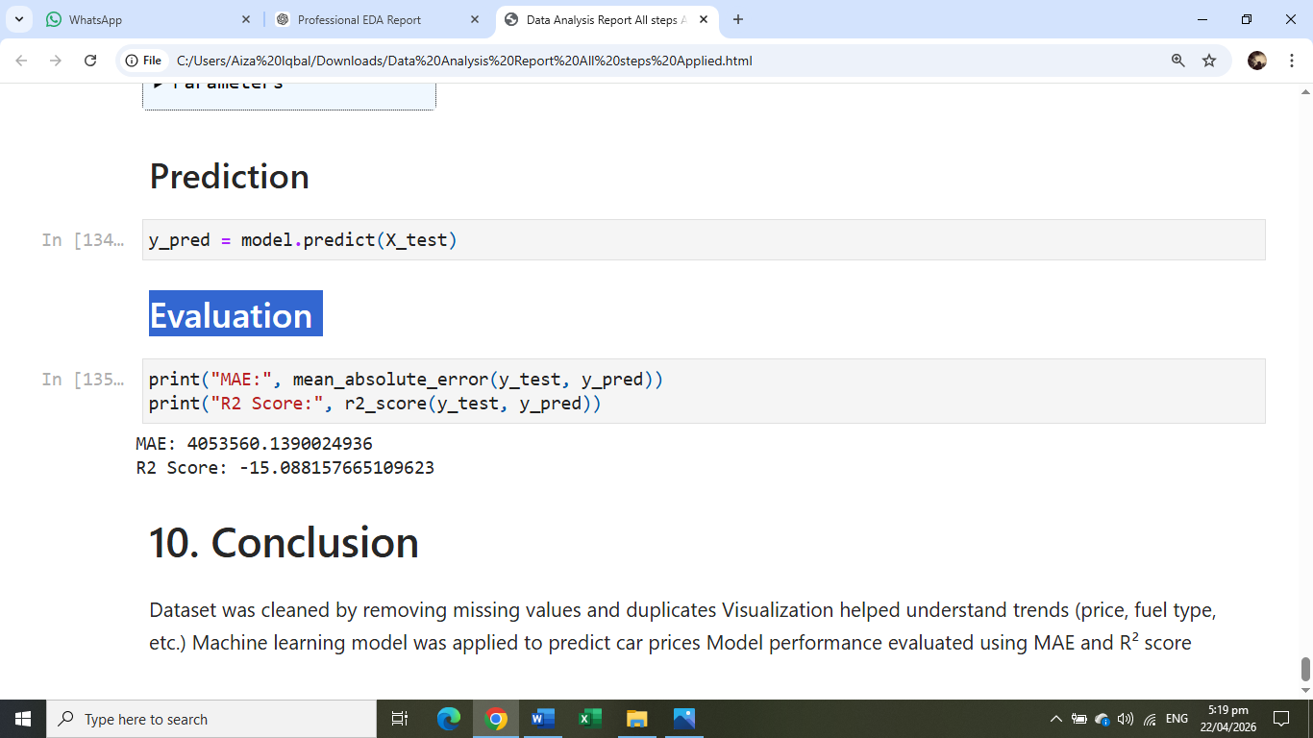

Explanation:
A simple linear regression model is used to predict price. Performance is checked using MAE and R² score.

11. Conclusion:
The dataset was successfully cleaned and analyzed. Visualizations helped identify patterns in price and features. Machine learning was applied for prediction, but further improvement can be done using more features.

